
The School of Technology
BSc (Hons) in Software Engineering
(Batch - 08)
Software Architecture and Design
4CS017
W. Udara Nethmi (2501573)
Module Leader: Ms. Suranji Nadeeshani
Submission Date: 06/11/2024

The weather app offers a user-friendly interface with simple design, allowing user to easily check the weather for any city. It uses localstotage to cache weather data, reducing redundant API calls and improving response times. If the data is unavailable in localstorage, it falls back to a PHP back-end, fetching data from either a local database or an external weather API. The app provides error handling and clear feedback for network or input issues. Its responsive design ensures a visually appealing experience across devices. However, the app has weaknesses, including limited caching , heavy reliance on the Open weather map API, lack of input validation, and security concerns like potential SQL injection risks. A more robust security approach is needed.

The architecture of the weather app is based on a client-server model. The front-end consists of HTML, CSS and Java Script, which handle user interactions, display, and API calls. Upon entering a city name, the Java Script first checks the localstorage for cached weather data. If unavailable, it triggers a request to a PHP back-end. The PHP script fetches data either from the local database or an external weather API, returning the data to the front-end. The database server as the primary storage for weather data, and the app uses it to minimize API calls, ensuring efficient performance. The app’s flow ensures that the user always gets up-to-date weather information, even if the API is temporary unavailable.

The codes are given below

This is my HTML Code
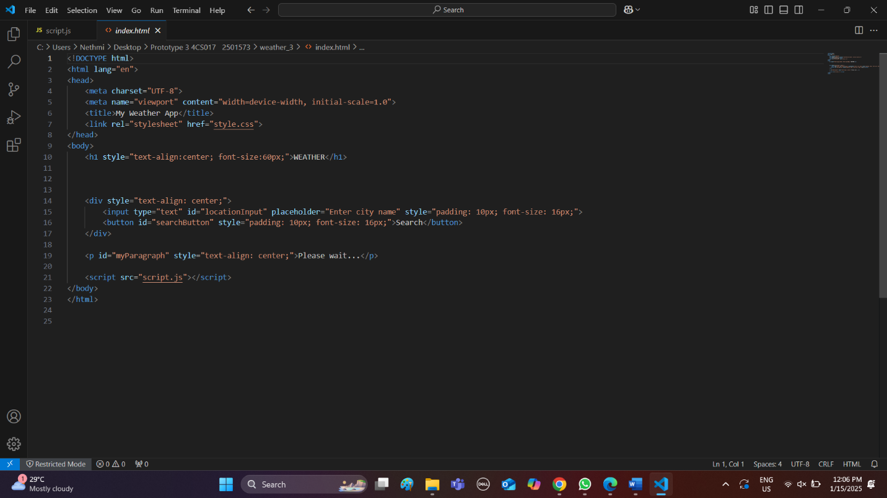

This is my CSS Code
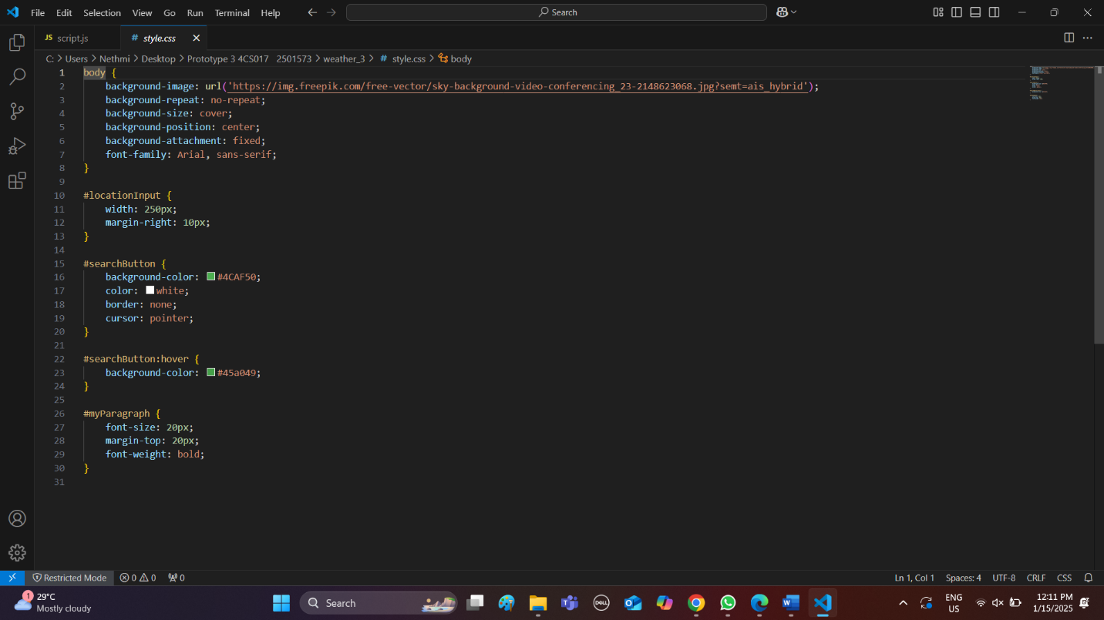

This is my Java Script Code
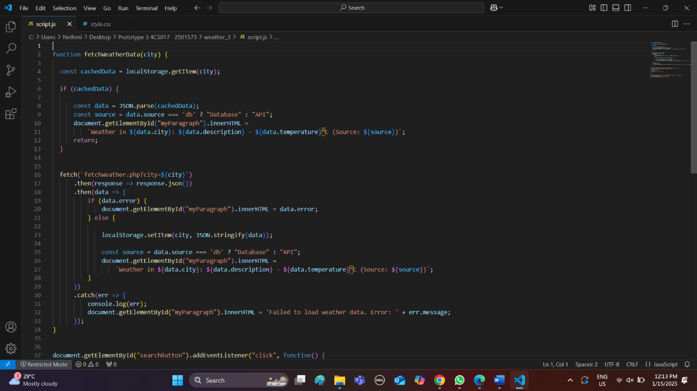

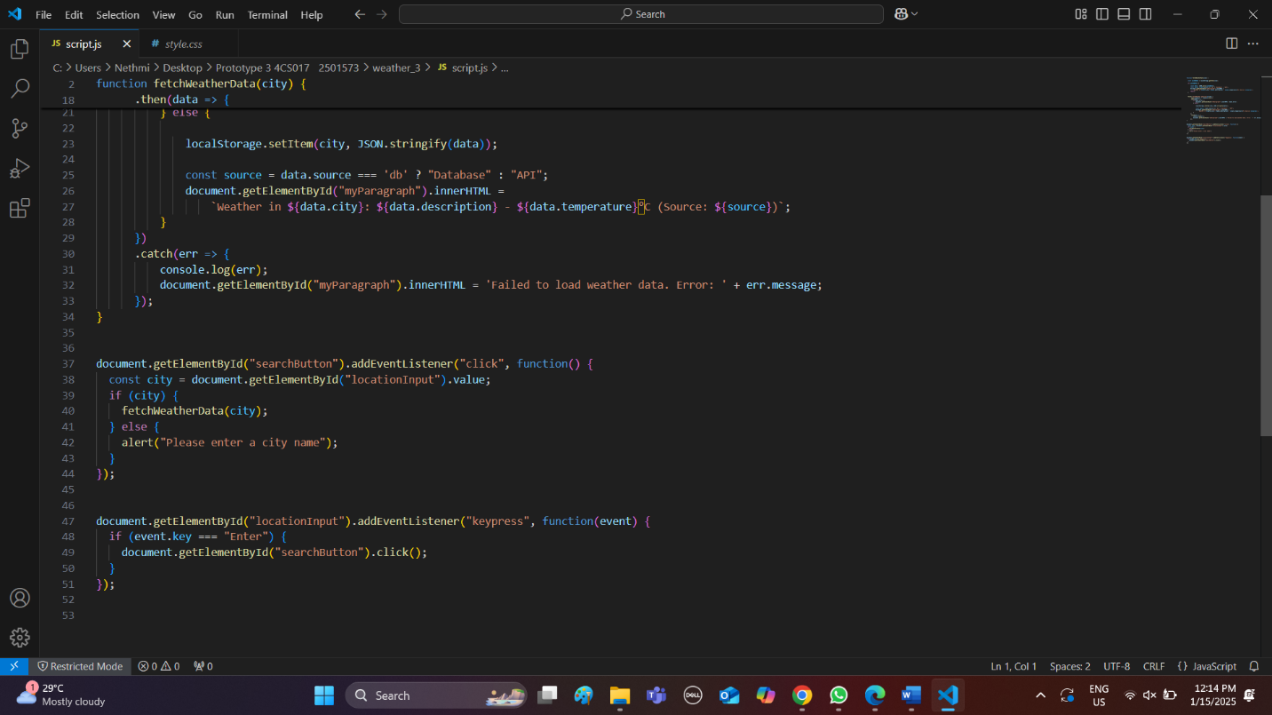
This is my PHP Code
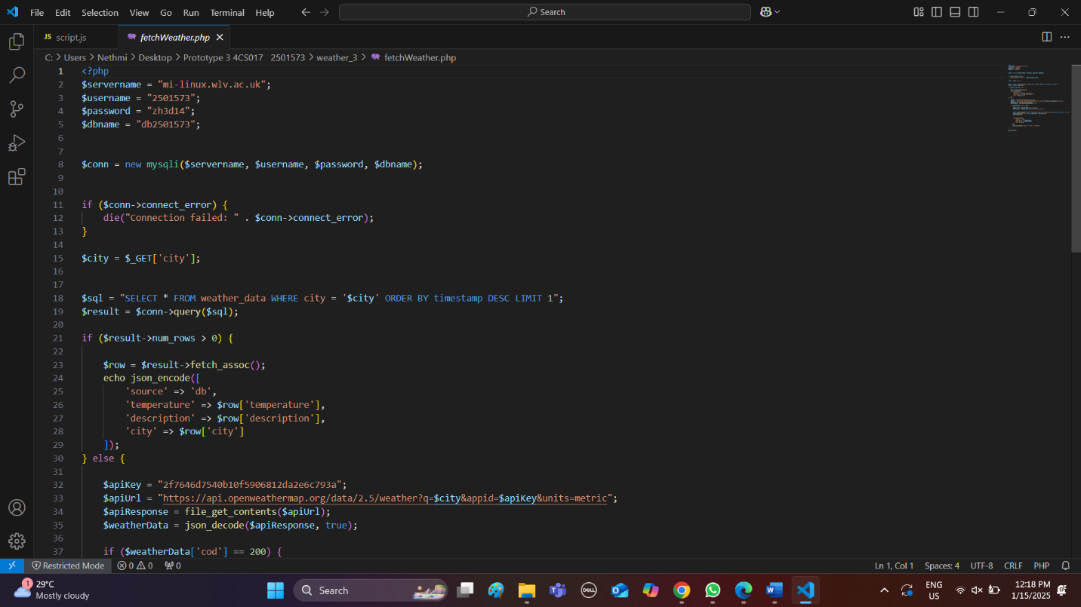

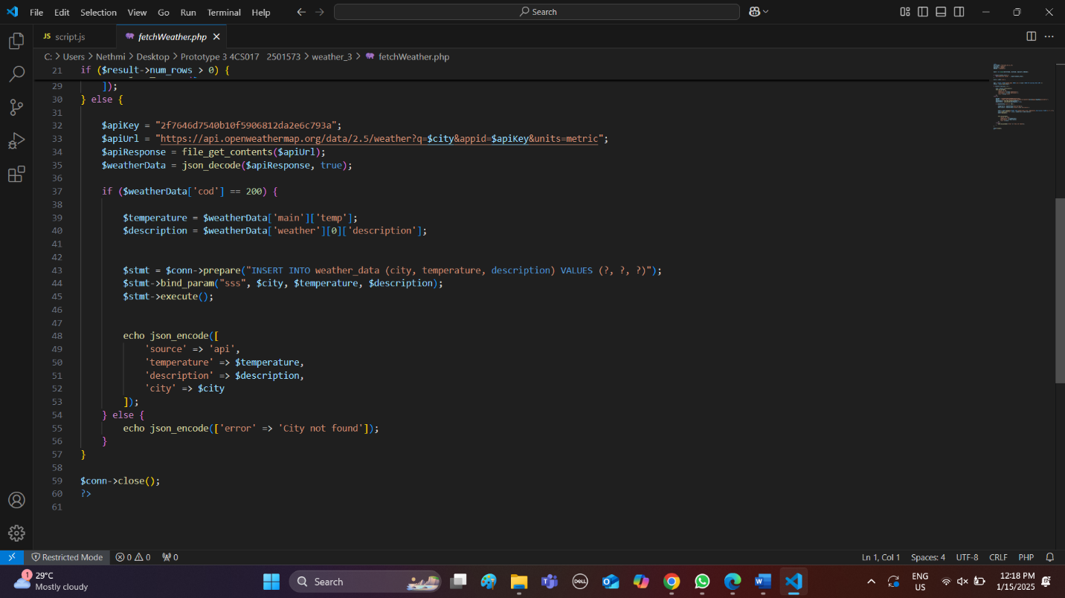

This is my Prototype 1 Weather app link
https://mi-linux.wlv.ac.uk/~2501573/weather/index.html
This is my Prototype 2 Weather app link
https://mi-linux.wlv.ac.uk/~2501573/nethmi_1.1/index.html

This is my Prototype 3 Weather app link
https://mi-linux.wlv.ac.uk/~2501573/weather_3/index.html

